Water soluble vitamins
L-ASCORBIC ACID (VITAMIN C)
Structure and metabolism | Functions |  | Deficiency
-Has strong reducing power due to the enolic hydrogens (-OH) at C2&C3.  -The D-ascorbic acid has no activity.  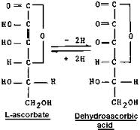  - dehydro ascorbic acid, oxidized further to oxalic acid.  which is excreted in urine | 1- Cofactors for many enzymes (Oxidation reduction reactions): |  | Scurvy  1. Hemorrhagic Tendency:  * Abnormal Collagen & brittle intercellular cement substance  * manifested as  - petechiae in mild deficiency - ecchymoses or even hematoma in severe conditions.  2.Oral Cavity: in severe cases,  * painful spongy swollen gum  *loose teeth that may fall.  3. Bones: Easy bone fractures (due to failure of the osteoblasts to form the intercellular substance, osteoid).  4. Anemia  1- Microcytic hypochromic anemia: due to:  * hemorrhage.  *↓ iron absorption.  2- Macrocytic hyperchromic anemia: due to ↓activation of folic acid to FH4 acid.  3- functional anemia: due to accumulation of met Hb  5. Delayed healing of wounds and increased liability for infections
 | enzyme | importance
 | Proline & lysine hydroxylases | Collagen synthesis (cross links)
 | 7 α-hydroxylase | Bile acid Synthesis
 | Steroid hydroxylases | Steroids synthesis in the adrenal cortex
 | Tryptophan hydroxylase | Tryptophan metabolism (synthesis of 5-OH tryptophan → serotonin synthesis)
 | Dopamine β-hydroxylase | Epinephrine synthesis from tyrosine
 | P-OH phenyl pyruvic dehydrogenase & homogentisic acid oxidase | Tyrosine metabolism
 | Folate &FH2 reductases | FH4 synthesis (active form)
2- Important for Hemopoiesis:
- ↑iron absorption by reducing ferric (Fe⁺³) to ferrous iron (Fe⁺²).
- FH4 synthesis
 | 3- water soluble Antioxidant
 | 4- ↑ body resistance by stimulating phagocytic action of leucocytes and helping in the formation of antibodies
 | 5- Vitamin C is concentrated in the lens of eye. Regular intake of ascorbic acid reduces the risk of cataract formation
 | 6- Hemoglobin Metabolism It is useful for re-conversion of met-hemoglobin to hemoglobin
Thiamine (Vitamin B1)
Structure and metabolism | Functions |  | Deficiency
Sulfur containing vitamin  Thiamine.  thiamine pyrophospho-transferase  ATP  AMP  Thiamine pyrophosphate (TPP) (Active form) | - Oxidative decarboxylation of alpha keto acids, e.g.  i. Pyruvate dehydrogenase complex pyruvate→acetyl CoA + CO2.  ii. Alpha ketoglutarate dehydrogenase: alpha ketoglutarate→succinyl CoA+ C02 (TCA cycle).  - Transketolase reaction: In HMP shunt. |  | Beriberi  beriberi; meaning "weakness".  Manifestations  •Nervous system manifestations:  -Peripheral N.S. manifestations:  peripheral neuritis,exhausion and inability to work.  -C.N.S manifestations:  in Wernicke-Korsakoff syndrome  •C.V.S. MANIFESTATIONS:  Heart failure and oedema  •Gastro intestinal manifestations:  Anorexia , nausea and vomiting  Types  The main types of beriberi are:  - Dry beriberi(without oedema) : affect the nervous system.  - Wet beriberi (with oedema): affects the cardiovascular system, as well as other bodily systems.  Causes  • in people whose diet consists mainly of polished white rice, which is very low in thiamine  • in breast-fed infants in mothers deficient in thiamine  • Impaired absorption in: - chronic alcoholics (Wernicke-Korsakoff syndrome)  - Prolonged diarrhea  - genetic beriberi  • Excess use in hyperthyroidism, pregnancy,lactation or fever.
Riboflavin (Vitamin B2)
Structure and metabolism | Functions |  | Deficiency
Riboflavin (Flavin ring + ribitol)  ATP  PPi  FAD (Flavin adenine dinucleotide) = flavin+ribitol+2 phosphate+ribose +adenine  FMN (Flavin mononucleotide) = Flavin + ribitol+phosphate  ADP  ATP | • FMN and FAD are coenzymes of oxidoreductase flavoprotein enzymes.They are tightly bound to these enzymes.  •FMN & FAD as coenzymes act as hydrogen carriers in oxidation/ reduction reactions. 2 hydrogen atoms are added to the flavin ring to form the reduced forms FMNH₂ & FADH₂. . They are reoxidised by molecular oxygen to produce hydrogen peroxide and FMN OR FAD.  A. FMN-dependent Enzymes:  1- L- amino acid oxidase.  α- amino acid→ α-keto acid.  2- In the respiratory chain, the NADH dehydrogenase contains FMN. The electrons are transported in the following manner. NAD+ FMN CoQ.  - FAD-dependent Enzymes:  1- D- amino acid oxidase.  2- Oxidative decarboxylation of α- keto acids as  - pyruvate dehydrogenase  Pyruvate → acetyl CoA  - α- keto-glutarate dehydrogenase  α- ketoglutarate to succinyl CoA  3- Succinate dehydrogenase.  Succinate → fumarate ( krebs cycle).  4- Acyl CoA dehydrogenase.  Acyl CoA →α-β enoyl CoA ( F.a oxidation).  5- Xanthine oxidase.  Hypoxanthine→Xanthine → uric acid (purine catabolism)  . |  | skin and mucous membranes are affected .  1-Angular stomatitis (Inflamation and fissuring at the angle of the mouth).  2.Glossitis ( Inflamation of the tongue).  3.Cheilosis (dry fissured lips).  4.Vascularization of cornea and photophobia (Inability to look to light).

Nicotinic Acid (Niacin) - Vitamin B3 - [Pellagra Preventing Factor (PPF)]
Structure and metabolism | Functions | Deficiency
Nicotinamide Nicotinic Acid  Nicotinic acid is the monocarboxylic acid derivative of pyridine ring. Nicotinamide is the amide form.  Niacin → active co-enzyme forms, •co-enzyme I [ Nicotinamide adenine dinucleotide (NAD+) ] = nicotinamide + 2 ribose + 2 phosphate +adenine]  •co-enzyme II [ Nicotinamide adenine dinucleotide phosphate (NADP+) ] = NAD+ + phosphate .  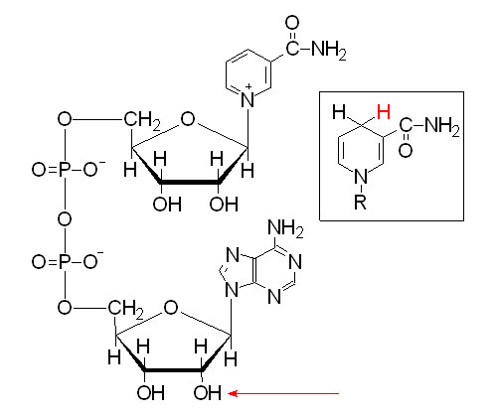  The –OH phosphorylated in NADP⁺ is indicated by the red arrow. NADH is shown in the box insert.  Sources:  - Diet  - Nicotinic acid is synthesized in the body from tryptophan. 60 mg of tryptophan gives I mg of niacin. | • NAD+ &NADP+ are coenzymes for many oxidoreductase enzymes. They act as hydrogen carriers  • NAD+ dehydrogenases catalyze oxidoreduction reactions in oxidative pathways  NADP+ dehydrogenases catalyze oxidoreduction reactions in reductive synthesis pathways | Pellagra  Manifestations  4 Ds  1. Dermatitis.  2. Diarrhea.  3. Dementia  4. Death.  Causes  1- Dietary deficiency of tryptophan: Maize is deficient in tryptophan, so population consuming maize as main constituent of diet deficiency occurs.  2- Hartnup disease (congenital disease): Defective tryptophan absorption from intestine  3- Defect in tryptophan conversion to → niacin in vit. B6 deficiency (pyridoxal phosphate).  One of the causes of vitamin B6 deficiency is intake of Isoniazid (INH) drug: It is an anti-tuberculous drug, that inhibits pyridoxal phosphate).  4- Carcinoid syndrome: The tumour utilizes major portion of available tryptophan for synthesis of serotonin; so tryptophan is unavailable.

Vitamin B6 (Pyridoxine-pyridoxal- Pyridoxamine)
Structure and metabolism | Functions | Deficiency
Vitamin B₆: - pyridine derivative  - include:  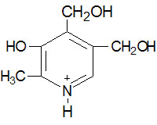  Pyridoxine  (Alchol)  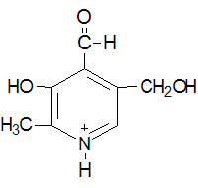  Pyridoxal  (Aldehyde)  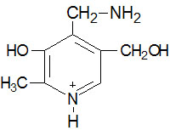  Pyridoxamine  Active form of pyridoxine is pyridoxal phosphate (PLP). It is synthesized by pyridoxal kinase, utilizing ATP.  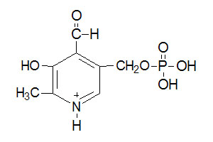  Pyridoxal phosphate | •PLP is coenzyme for many enzymes:  - Transaminases  - a.a. decarboxylases  a- Glutamate → GABA (inhibitory neurotransmitter), (B6 deficiency→convulsions)  b- Histidine→histamine ( mediator of allergy and anaphylaxis).  c- 5-HT → serotonin.  - Cysta thionine synthase and Cystathionase  In Vitamin B6 deficiency homocysteine in blood is increased. Homocysteine level is correlated with myocardial infarction.  - kynureninase enzyme  (tryptophan→ niacin)  5- ALA synthase  1st and rate limiting step in heme biosynthesis.  6- Muscle glycogen  Phosphorylase enzyme (glycogen → glucose-l-P). More than 70% of total PLP content of the body is in muscles, where it is a part of'the phosphorylase enzyme.  - The enzyme condensing palmityl CO A and serine to form sphingosine  •It helps the absorption of amino acids from intestine and its uptake by the cells | Manifestations ( 4)  1-Neurological Manifestations:  irritability, convulsions and peripheral neuritis,  •serotonin, epinephrine, noradrenaline and gamma-aminobutyric acid (GABA) are not produced properly.. In children, B6 deficiency leads to convulsions due to decreased formation of GABA.  •PLP is involved in the synthesis of sphingolipids; so B6 deficiency →demyelination of nerves → peripheral neuritis occurs.  2. Dermatological Manifestations  as pellagra.  3. Hematological Manifestations  In adults hypochromic microcytic anemia may occur due to the inhibition of heme , biosynthesis.  - Impaired growth of children  due to disturbed amino acid metabolism.Drugs affecting vitamin B6  1.INH: It inhibits pyridoxal kinase; →↓formation ofPLP  2.Ethanol: it is converted to acetaldehyde which inactivates PLP, so vit. B6 deficiency neuritis is common'in alcoholics.  3.Oral contraceptives pills: women taking these pills will produce mild deficiency manifestation.

Vitamin B5 (Pantothenic acid)
Functions |  | Deficiency
- It enters in the formation of COASH :  COASH activity is due to SH group at its end which act as a carrier of acyl group (R-CO-) with high energy thioester linkage (R-CO~SCOA)  This occurs in  - Fatty acid oxidation and synthesis  - Oxidative decarboxylation of α-keto acids  - Pyruvic acid→active acetate (Acetyl COA) →oxidized in krebs cycleto give energy or enter in the synthesis of cholesterol, steroid hormones, ketone bodies and acetylcholine and other acetylation reactions.  - α-ketoglutaric →active succinate (Succinyl COA) →synthesis of heme,  ketolysis  detoxification  gluconeogenesis.  2. Pantothenic acid enters in acyl carrier protein structure (ACP). It is a co-enzyme necessary for the synthesis of fatty acid. |  | Gopalan's Burning foot syndrome  Rare because it is widely found in food  Of its Manifestations  1- burning pain in lower extremities.  2- Normocytic normochromic anaemia.
Folic acid (Pteroglutamic acid)
Structure and metabolism | Functions |  | Deficiency
Folic Acid  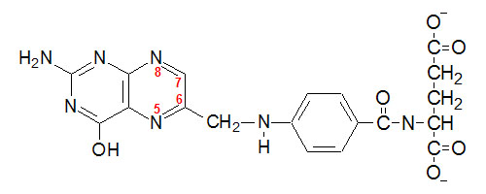  OH  OH  PABA  (p- amino benzoic acid)  6- methyl pteridine  Glutamic acid  Pteroic acid  - Positions 7 and 8 carry hydrogens in dihydrofolate (FH2)  - Positions 5,6,7,8 carry hydrogens in tetrahydrofolate (FH4) | In our tissues folic acid is first reduced to FH2 and further reduced to FH4 . Both reactions are catalysed by NADPH dependent folate reductase .  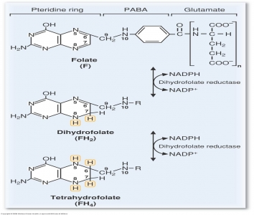  Vit.C C  Vit. C  FH4 is the carrier of one-carbon groups.  - One carbon compound (unit) is an organic molecule that contains only a single carbon atom.  - The following groups are one carbon compounds:  - Formyl (-CHO)  - ii. Formimino (-CH=NH)  - iii. Methenyl (-CH=)  - iv. Methylene (-CH2-)  - v. Hydroxymethyl (-CH20H)  - vi. Methyl (-CH3).  - One carbon unit maybe attached to N-5 or N-10 or both.  - Methyl group in N5-methyl FH4 is used for synthesis of active methionine, which takes part in transmethylation reactions Such transmethylation reactions are required for synthesis of choline, epinephrine, creatine, etc.  Homocysteine + N5-methyl FH4  Methionine synthase  Vit. B12  Methionine + FH4 |  | Manifestations  Folic acid is important for purine and dTTP and thus needed for DNA and RNA synthesis  So, Folate deficiency lead to ↓DNA and RNA synthesis → •Impaired hemopoiesis •impaired growth  • impaired intestinal mucosal absorption.  So manifestations are:  1- Megaloblastic anemia (Macrocytic hyperchromic anemia).  2- Leucopenia and thrombocytopenia.  3- impaired growth in children  4- gastrointestinal disturbances.  5-Fetal malformations e.g. Spina bifida, so intake of folic acid is must in early months of pregnancy.  Causes  - Dietary deficiency 2)↑requirements as in pregnancy and hemolytic anemias  3) Defective absorption: In sprue, celiac disease, and in gastroileostomy,  4) Drugs: Anticonvulsant drugs (hydantoin, dilantin, phenytoin, phenobarbitone) will inhib.: the intestinal enzymes, so that folate absorption is reduced.  5) Folate trap: Generation of free FH4 needs vit. B 12. When B 12 is deficient, no free FH4 leading to folate deficiency.  Diagnosis  By Figlu excretion test : Loading oral dose of histidine is given to the subject and the excretion of formiminoglutamate (Figlu) is determined in urine. Increase excretion in urine indicate folate deficiency  Folic acid therapy  Folic acid alone should not be given in macrocytic anemia. Because it may aggravate the neurological manifestation of B12 deficiency. So, folic acid and vitamin B12 are given in combination to patients.

Vitamin B12
Structure and metabolism | Functions | Deficiency
Chemistry: FOR READING  Consist of Corrin ring formed of Four pyrrole rings coordinated with a cobalt atom. the cobalt is bound to any of the following groups: cyanide, hydroxyl, adenosyl or methyl forming:  - Cyanocobalamin  - Hydroxy cobalamin  - . Adenosyl cobalamin :This is the major storage form, seen in liver.  - Methyl cobalamin: This is the major form seen in blood.  Absorption:  Vitamin B12 combines with the intrinsic factor of Castle secreted by the gastric parietal cells to be absorbed . Hence the B12 is the extrinsic factor . | Functions:  - Coenzyme for methionine synthase:  Homocysteine + N5-methyl FH4  Methionine synthase  Vit. B12  Methionine + FH4  - Methionine is important for transmethylation reactions so important for phosphatidyl choline synthesis which is important for phospholipid synthesis, important for myelin sheath formation. So vit. B12 deficiency lead to neurological manifestations.  - Released FH4 is important for purine and dTTP important in hemopoeisis. So vit.B12 deficiency lead to accumulation of methyl FH4 (Folate trap) and thus FH4 deficiency → impair DNA synthesis → prevent cell division and formation of DNA for the new erythrocytes→ megaloblastic anemia  2- Coenzyme for methylmalonyl COA mutase:  Propionyl COA → methylmalonyl COA  methylmalonyl COA mutase  Vit.B12  Succinyl COA  - Succinyl COA is important for heme synthesis  - In vit. B12 deficiency, large amounts of propionyl COA & methylmalonyl COA are forme leading to increase formation of odd chain and branched chain f.as which accumulate in the myelin sheath→ neurologic manifestations | Manifestations:  1) Megaloblastic anemia.  2) Peripheral neuritis  3) Retarded growth in children  4) gastrointestinal disturbances  5) homocystinuria and methylmalonyl aciduria  Causes FOR RRADING  - Nutritional deficiency.  - Decrease in Absorption: Absorptive surface is reduced in gastrectomy and malabsorption syndromes , achlorhydria ( Absence of acid in gastric juice) and gastric Atrophy( In chronic iron deficiency anemia, there is generalised mucosal atrophy).  - increased requirement as in pregnancy.  Treatment  All macrocytic anemias are generally treated with folate and vitamin B12 .

BIOTIN
- It is a sulfur containing vitamin synthesized by the intestinal bacterial flora.
- Functions: Coenzyme for carboxylation reactions.
- Acetyl CoA carboxylase: Acetyl CoA Malonyl CoA
This is the rate limiting reaction in biosynthesis of fatty acids .
2) Pyruvate carboxylase: Pyruvate →Oxaloacetate
Important for TCA cycle & gluconeogenesis.
- Biotin Antagonists:
Avidin, a protein present in egg white bind tightly to biotin preventing its absorption. Hence intake of raw egg may cause biotin deficiency, It is heat labile, and boiling of egg will cause denaturation of avidin.
- Deficiency of biotin:
Causes: Prolonged use of antibiotics. Intake of raw egg white which contains avidin.

